Reexam 2023

Problem 1
- Both players have strictly dominant strategies in L and R respectively leadning us to a unique NE for the non repeated game in $NE:(L,R)$
Leadnig to utility $\left(1,1\right)$
- In any finitely repeated game rational players will always play their strictly dominant strategies(if they have them) in general any EQ strategy profile will be the unique NE played EVERY round
Any player must deviate in the last round since they have no incentive to keep a deal that theyve made(directly or indirectly) thus in the last round they will always play the NE but this means that in the next to last they must also play their best moves, since there are no possible consequences
This argument holds all the way back to the first game
Meaning that they get 1 each every round and thus get average payoff of 1

- They have 2 psossible moves in each desicion node we then count the decision nodes drawing the game tree we see that there are 5 subgames meaning that we have
$$2^{5}=32$$
Strategy for each player
A stragey is deciding what to do in every decision node Even the ones you dont reach given ”correct” play
In each decision node we have exacly 2 possibilities any cobination of these is a valid strategy and thus we simply multiply
32 is the answer

- Any convex combination of payoffs are feasible payoffs
To show that $\left(\begin{aligned}2 \\ 2\end{aligned}\right)$ is a convex combination see
$$\frac{1}{3}\left(\begin{aligned}1 \\ 1\end{aligned}\right)+\frac{2}{3}\left(\frac{1}{2}\left(\begin{aligned}5 \\ 0\end{aligned}\right)+\frac{1}{2}\left(\begin{aligned}0 \\ 5\end{aligned}\right)\right)=\left(\begin{matrix}2 \\ 2\end{matrix}\right)$$
- See the path $(L,R)(U,R)(L,L)$
This gives player 1 average payoff
$${\overline{v}}_{1}=\left(1-δ\right)\left(\frac{1}{1-δ^{3}}+\frac{5δ}{1-δ^{3}}\right)=\left(1-δ\right)·\left(\frac{5·δ}{1-δ^{3}}+\frac{1}{1-δ^{3}}\right)$$
$$=\frac{1+5δ}{1+δ+δ^{2}}$$
$${\overline{v}}_{2}=\left(1-δ\right)\left(\frac{1}{1-δ^{3}}+\frac{5δ^{2}}{1-δ^{3}}\right)=\frac{1+5δ^{2}}{1+δ+δ^{2}}$$
For $δ$ close to 1 this gives the average payoff of 2 for each player

- The grim trigger strategy is usually the way to go
Meaning
Player 1 plays
$$σ_{1}=\left\{\begin{aligned}LULLUL…if 2 plays RRLRRL… \\ LLLLL…if 2 ever deviates\end{aligned}\right.$$
$$σ_{2}=\left\{\begin{aligned}RRLRRL…if 1 plays LULLUL… \\ RRRRR…if 1 ever deviates\end{aligned}\right.$$
I check subgame perfection via the 1.step deviation principal
For player 1:
When will he deviate?
$\left(L,R\right)$ is best response thus he will not deviate
$\left(U,R\right)$ is best response thus he will not deviate
$(L,L)$ deviating might make sense: when does it make sense
$$u^{div}=\frac{1}{1-δ}$$
$$u^{ndiv}=\frac{δ}{1-δ^{3}}+\frac{5δ^{2}}{1-δ^{3}}$$
When is the utility of deviating higher?
$$\frac{1}{1-δ}≥\frac{δ}{1-δ^{3}}+\frac{5δ^{2}}{1-δ^{3}}$$
$⇕$ Uligheden løses for delta vha. WordMat.
$$\left(δ≥-\left(\frac{1}{2}\right) ∧ δ≤\frac{1}{2}\right)$$
Makes sense for $δ≤\frac{1}{2}$

For player 2:

When will he deviate?
$\left(L,R\right)$ is best response thus he will not deviate
$(L,L)$is best response thus he will not deviate
$\left(U,R\right)$ deviating might make sense: when does it make sense

$$u^{div}=\frac{1}{1-δ}$$
$$u^{ndiv}=\frac{5δ}{1-δ^{3}}+\frac{δ^{2}}{1-δ^{3}}$$
When is it better to deviate?
$$\frac{1}{1-δ}≥\frac{5δ}{1-δ^{3}}+\frac{δ^{2}}{1-δ^{3}}$$
$⇕$
$$δ≤\frac{1}{4}$$
These 2 put together mean that we need $δ≥\frac{1}{2}$ for this to be a SPNE

Problem 2

- A has a strictly dominant strategy in u
B knows this and wil thus always play L giving us a unique NE(since its the unique survivor of iesds) in $NE:(u,L)$
Giving payoff $(4,4)$
- I draw the game tree:
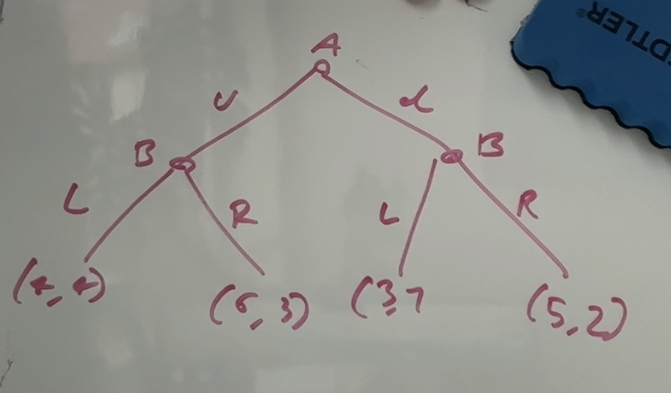
And use backwards induction to find the SPNE(which turns out to be unique)
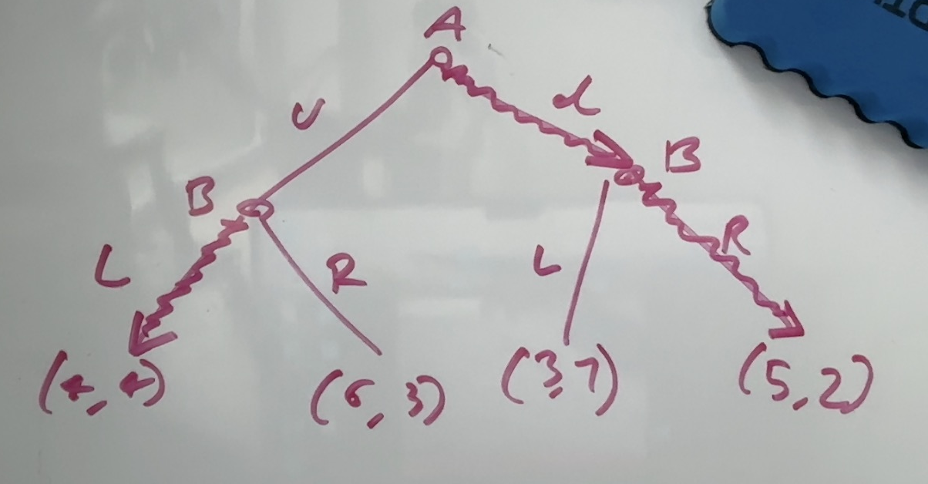
Or $SPNE=\left(L,LR\right)$
Where $L$ is played in the ”u” state and R is played in the ”d” state

- I draw the game tree
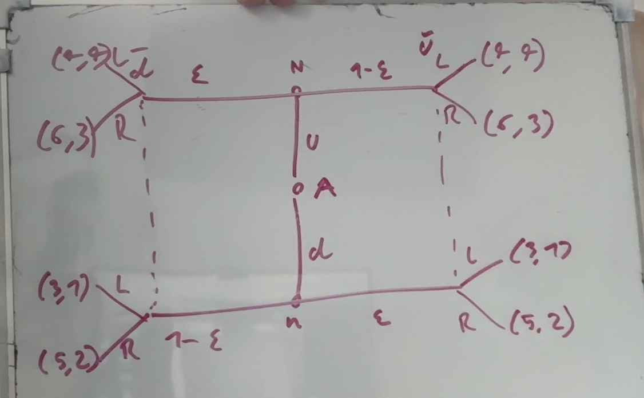

I check for seperating EQ first and then Pooling with $μ=P(u)$
Seperating EQ
$L\left|\overline{d},R\right|\overline{u}$:
$$u_{A}\left(u\right)=ϵ·4+\left(1-ϵ\right)·6=6-2ϵ$$
$$u_{A}\left(d\right)=\left(1-ϵ\right)·3+ϵ·5=3+2ϵ$$
Hvornår vælges hvad?
$$6-2ϵ≥3+2ϵ$$
$⇕$ Uligheden løses for epsilon vha. WordMat.
$$ϵ≤\frac{3}{4}$$
If u is choosen will B deviate?
Yes
In $\overline{u}$ B prefers L meaning this is never a seperating EQ

If d is choosen will B deviate?
Yes B prefers RR

What if $ϵ=\frac{3}{4}$ are there then any $μ$ that makes this EQ viable?
Yes there are
$$μ=\frac{1}{2}$$
Means $u_{B}\left(L\right)=2,5=u_{B}(R)$
Thus $L\left|\overline{d},R\right|\overline{u}$ is a valid seperating EQ for u and d actually played with $ϵ=\frac{3}{4},μ=\frac{1}{2}$
$R\left|\overline{d},L\right|\overline{u}$:
A gets utility
$$u_{A}\left(u\right)=6ϵ+\left(1-ϵ\right)·4=4+2ϵ$$
$$u_{A}\left(d\right)=5·\left(1-ϵ\right)+ϵ·3=5-2ϵ$$
$$4+2ϵ≥5-2ϵ$$
$⇕$ Uligheden løses for epsilon vha. WordMat.
$$ϵ≥\frac{1}{4}$$
u is preffered for $ϵ≥\frac{1}{4}$
will B deviate then?
Yes he preffers pooling on L
d is preffered for $ϵ<\frac{1}{4}$
does B want to deviate? Yes B prefers pooling on R
again it is EQ for $ϵ=\frac{1}{4},μ=\frac{1}{2}$

Pooling EQ:
RR
A plays u
B prefers pooling on L thus never and EQ

LL
A plays u
B dosent want to deviate
We have an EQ in the exact NE we had in part 1

There are some PBE but for any epsilon the only one that works is
The original NE
Pooling on L with A playing u
$$PBE=(LL,u)$$

c) we know that one dosent nessesarily imply the other
the addition of randomness and beliefs remove the viability of the SPNE

Problem 3
$$π_{H}=850,π_{L}=200$$
$$P\left(π_{H} | W\right)=\frac{3}{5}$$
$$P\left(π_{H} | S\right)=\frac{1}{5}$$
$$Π\left(π,c\right)=π-c$$
$$u\left(c,e\right)=\sqrt{c }-g\left(e\right)$$
$$g\left(W\right)=10$$
$$g\left(S\right)=5$$
$$\overline{u}=2$$
- First Best
- I write up the problem
$$\max_{c_{H},c_{L},e}{P_{e}·\left(π_{H}-c_{H}\right)+\left(1-P_{e}\right)\left(π_{L}-c_{L}\right)}$$
$$\begin{aligned}s.t. P_{e}·\sqrt{c_{H}}+\left(1-P_{e}\right)\sqrt{c_{L}}-g\left(e\right)≥\overline{u}\#\left(PC\right)\end{aligned}$$
- I solve the problem for general First best
We know that PC must be binding, otherwise simply decrease c_L or C_H
I set up the lagrangian
$$L=P_{e}·\left(π_{H}-c_{H}\right)+\left(1-P_{e}\right)\left(π_{L}-c_{L}\right)+λ\left(P_{e}·\sqrt{c_{H}}+\left(1-P_{e}\right)\sqrt{c_{L}}-g\left(e\right)-\overline{u}\right)$$
Find FOC
$$\begin{aligned}\frac{∂L}{∂c_{H}}=-P_{e}+λ·\frac{P_{e}}{2\sqrt{c_{H}}}=0\#1\end{aligned}$$

$$\begin{aligned}\frac{∂L}{∂c_{L}}=-\left(1-P_{e}\right)+\frac{\left(1-P_{e}\right)}{2\sqrt{c_{L}}}=0\#2\end{aligned}$$

$$\begin{aligned}\frac{∂L}{∂λ}=0⇔P_{e}·\sqrt{c_{H}}+\left(1-P_{e}\right)\sqrt{c_{L}}-g\left(e\right)=\overline{u}\#3\end{aligned}$$
1 and 2 imply $C_{H}=C_{L}=C$
Plugging into 3 we get
$$\sqrt{C}-g\left(e\right)=\overline{u}$$
Now for ”W”
$$\sqrt{C}-10=2⇔C={12}^{2}=144$$
Giving the contract play W and get compensation $C_{H}=C_{L}=144$

- Now for ”S”
$$\sqrt{C}-5=2⇔C=7^{2}=49$$

Giving the contract play S and get compensation $C_{H}=C_{L}=49$

- I calculate the expected utilities
$$E\left[Π_{W}^{FB}\right]=\frac{3}{5}·\left(850-144\right)+\frac{2}{5}·\left(200-144\right)=446$$
$$E\left[Π_{S}^{FB}\right]=\frac{1}{5}\left(800-49\right)+\frac{4}{5}·\left(200-49\right)=271$$
- Since implementing W has higher expected profits shareholders prefer to implement effort level W
With the compensation
$$C_{H}=C_{L}=144$$
- Second best:
- I write up the problem when implementing W
$$\max_{C_{H},C_{L}}{\frac{3}{5}\left(π_{H}-C_{H}\right)+\frac{2}{5}\left(π_{L}-C_{L}\right)}$$
$$\begin{aligned}s.t\frac{3}{5}\sqrt{C_{H}}+\frac{2}{5}\sqrt{C_{L}}-g\left(W\right)≥\overline{u}\#\left(PC\right)\end{aligned}$$

$$\begin{aligned}\frac{3}{5}\sqrt{C_{H}}+\frac{2}{5}\sqrt{C_{L}}-g\left(W\right)≥\frac{1}{5}\sqrt{C_{H}}+\frac{4}{5}\sqrt{C_{L}}-g\left(S\right)⇔\left(\frac{3}{5}-\frac{1}{5}\right)\left(\sqrt{C_{H}}-\sqrt{C_{L}}\right)≥g\left(W\right)-g(S)\#\left(IC\right)\end{aligned}$$
- I write up the lagrangian
$$L=\frac{3}{5}\left(π_{H}-C_{H}\right)+\frac{2}{5}\left(π_{L}-C_{L}\right)+λ\left(\frac{3}{5}\sqrt{C_{H}}+\frac{2}{5}\sqrt{C_{L}}-g\left(W\right)-\overline{u}\right)$$
$$+μ·\left(\left(\frac{3}{5}-\frac{1}{5}\right)\left(\sqrt{C_{H}}-\sqrt{C_{L}}\right)-\left(g\left(W\right)-g\left(S\right)\right)\right)$$
Ill argue that both must be binding and then solve a system of equations
I write up FOC
$$\begin{aligned}\frac{∂L}{∂C_{H}}=-\frac{3}{5}+λ·\frac{3}{5}·\frac{1}{2\sqrt{C_{H}}}+μ·\left(\frac{3}{5}-\frac{1}{5}\right)·\frac{1}{2\sqrt{C_{H}}}=0\#\left(1\right)\end{aligned}$$
$$\begin{aligned}\frac{∂L}{∂C_{L}}=-\frac{2}{5}+\frac{2}{5}λ·\frac{1}{2\sqrt{C_{L}}}-μ·\left(\frac{3}{5}-\frac{1}{5}\right)·\frac{1}{2\sqrt{C_{L}}}=0\#\left(2\right)\end{aligned}$$
PC is binding:
Since $μ≥0 \left(2\right)⇒λ>0$ and thus PC is binding

IC is binding:
AFC $μ=0$
Then FOC become
$$\begin{aligned}\frac{∂L}{∂C_{H}}=-\frac{3}{5}+λ·\frac{3}{5}·\frac{1}{2\sqrt{C_{H}}}=0\#\left(1\right)\end{aligned}$$
$$\begin{aligned}\frac{∂L}{∂C_{L}}=-\frac{2}{5}+\frac{2}{5}λ·\frac{1}{2\sqrt{C_{L}}}=0\#\left(2\right)\end{aligned}$$
$$\frac{∂L}{∂λ}=0$$

Which is exactly from where we got the FB solution
We check if solution is valid remember that $C_{L}=C_{H}$ in first best
$$\left(\frac{3}{5}-\frac{1}{5}\right)\left(\sqrt{C_{H}}-\sqrt{C_{L}}\right)=0<10-5$$
Thus the FB solution is not valid and $μ>0$ and thus IC must be binding

From the fact that both PC and IC are binding in optimum we get the solution:

$$\left(\frac{3}{5}-\frac{1}{5}\right)\left(\sqrt{C_{H}}-\sqrt{C_{L}}\right)=10-5$$
$$\frac{3}{5}\sqrt{C_{H}}+\frac{2}{5}\sqrt{C_{L}}-10=2$$
$⇕$ Ligningssystemet løses for C_H,C_L vha. WordMat's 'Løs Ligninger' funktion,
$$C_{H}=289 ∧ C_{L}=\frac{81}{4}$$
For the BOD to impliment W they offer the constract
$$C_{H}=289,C_{L}=\frac{81}{4}$$

- The first best solution still works
I simply check the IC constraint
$$\left(\frac{1}{5}-\frac{4}{5}\right)\left(\sqrt{C_{L}}-\sqrt{C_{H}}\right)≥g\left(S\right)-g(W)$$
$$LHS=0$$
$$RHS=-5$$
The inequaliy holds giving us the second best solution equalint to the first best one
$$C_{H}=C_{L}=49$$
- I calculate expected profits

$$E\left[Π_{W}^{SB}\right]=\frac{3}{5}·\left(850-289\right)+\frac{2}{5}\left(200-\frac{81}{4}\right)=\frac{817}{2}=408,5$$
$$E\left[Π_{S}^{SB}\right]=E\left[Π_{S}^{FB}\right]=\frac{1}{5}\left(800-49\right)+\frac{4}{5}·\left(200-49\right)=271$$
Shareholders should still implement W getting
$$408,5>271$$
Utility
With the compensation
$$C_{H}=289,C_{L}=\frac{81}{4}$$
- The loss of not observing we calculate to the difference between expected utility in the 2 ”states”
$$408,5-446=-37,5$$
The BOD loose 37.5 utility on the fact that they cannot observe effort

Problem 4
- I set up
$$π_{H}=P_{H}-8000-500Y$$
$$π_{L}=P_{L}-5000-2000Y$$
Can we construct belief such that
$$P_{L}=7000$$
$$P_{H}=10000$$
With $Y=1$ yes
$$μ\left(y\right)=\left\{\begin{aligned}1 for y≥1 \\ 0 otherwise\end{aligned}\right.$$
$$P\left(y\right)=\left\{\begin{aligned}10000 for y≥1 \\ 7000 otherwise\end{aligned}\right.$$
$$y\left(type\right)=\left\{\begin{aligned}1 for H \\ 0 L\end{aligned}\right.$$
Will each type deviate?
H:
Not deviating gives profit $10000-8000-500=1500$
Deviating gives profit $7000-8000=-1000$
H does not want to deviate

L:
Not deviating gives
$$7000-5000=2000$$
Deviating gives $10000-5000-2000=3000$

If im supposed to assume that deviation means that we swap into a pooling EQ
Larry deviating gives him utility
$$8500-5000-2000=1500<2000$$
Meaning he prefers the seperating EQ

- by same calculations as before then L gets
$$8500-5000-1000=2500>2000$$
Meaning he prefers to match and get 8500 instead going into a pooling EQ

2 year warrenty
Then H prefers seperating to pooling since
$$10000-8000-1000=1000>500=8500-8000$$
L also prefers pooling since
$$2000>8500-5000-2000=1500$$
Meaning that signalling with 2 year warrenty gives a seperating EQ
- I would recomend to offer the lowest warenty where L still prefers the seperating EQ
$$2000≥3500-1000·Y$$
$⇕$ Uligheden løses for Y vha. WordMat.
$$Y≥\frac{3}{2}$$
I would recomend him offering 1.5 years of warrenty
Then he maximizes his profits while L still desent have incentive to deviate

